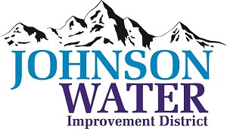

3748 West Highway 87

Roosevelt, UT 84066

Phone (435) 722-2620

October 13, 2025

SUBJECT: Work Meeting

**The Work Meeting** is Tuesday, October 14th @6:00 p.m.

**Agenda**:

1. Policies update
2. Pleasant Valley Connector Line
3. Interviewed Candidates
4. The Lead/Copper Money
5. Old Business:
6. Closed Session: Purpose listed in the Utah Code 52-4-205 (1) (d)