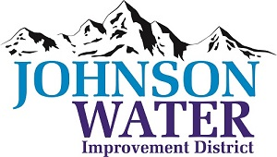
3748 West Highway 87
Roosevelt, UT 84066
Phone (435) 722-2620
May 21, 2026

SUBJECT: Regular Board Meeting and Public Hearing

The Board Meeting is Thursday, May 21, 2026 @ 6:30 pm.
Agenda:

- Appointments:
  - Sunrise
- Public input on issuance of Bonds for East System Improvements
- Updates on Construction Projects
- Independence Connector
- East System Improvements
  - Jones & DeMille
- Master Plan Update

- Cost of Lost Crop – 9000 S.

- Manager Report:
  - Contracts
  - Update on Projects
  - SCADA
  - Rate increase/Tiered rates

- Old Business:

- Closed Session: Purpose listed in the Utah Code 52-4-205 (1) (d)

